„What a dream I had, dressed in organdy
clothed in crinoline of smoky burgundy...“(Simon and Garfunkel)

In my eyes  most beatiful ground  if heaven can be found  pink and yellow butterflies  green sunny meadow  sky of cristal blue  with sun ball  and no shadow  at all. | 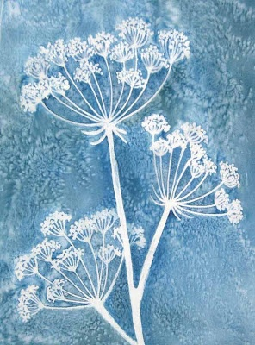 | Pure joy  ultimate delight  like child with new toy  running freely in sunlight  among irises and lilies  aubergine and purple trees  grasshopper plays  with me.
Then I saw  coaches and horses  of black and white  staircase in marble  luxurious court  king's resort  adorable sight. |  | I woke up.  But the scene  remains  in my eyes'  remembrance.  My heart and I we rise  and dance and dance...  there is a chance...  of paradise.
Angela

